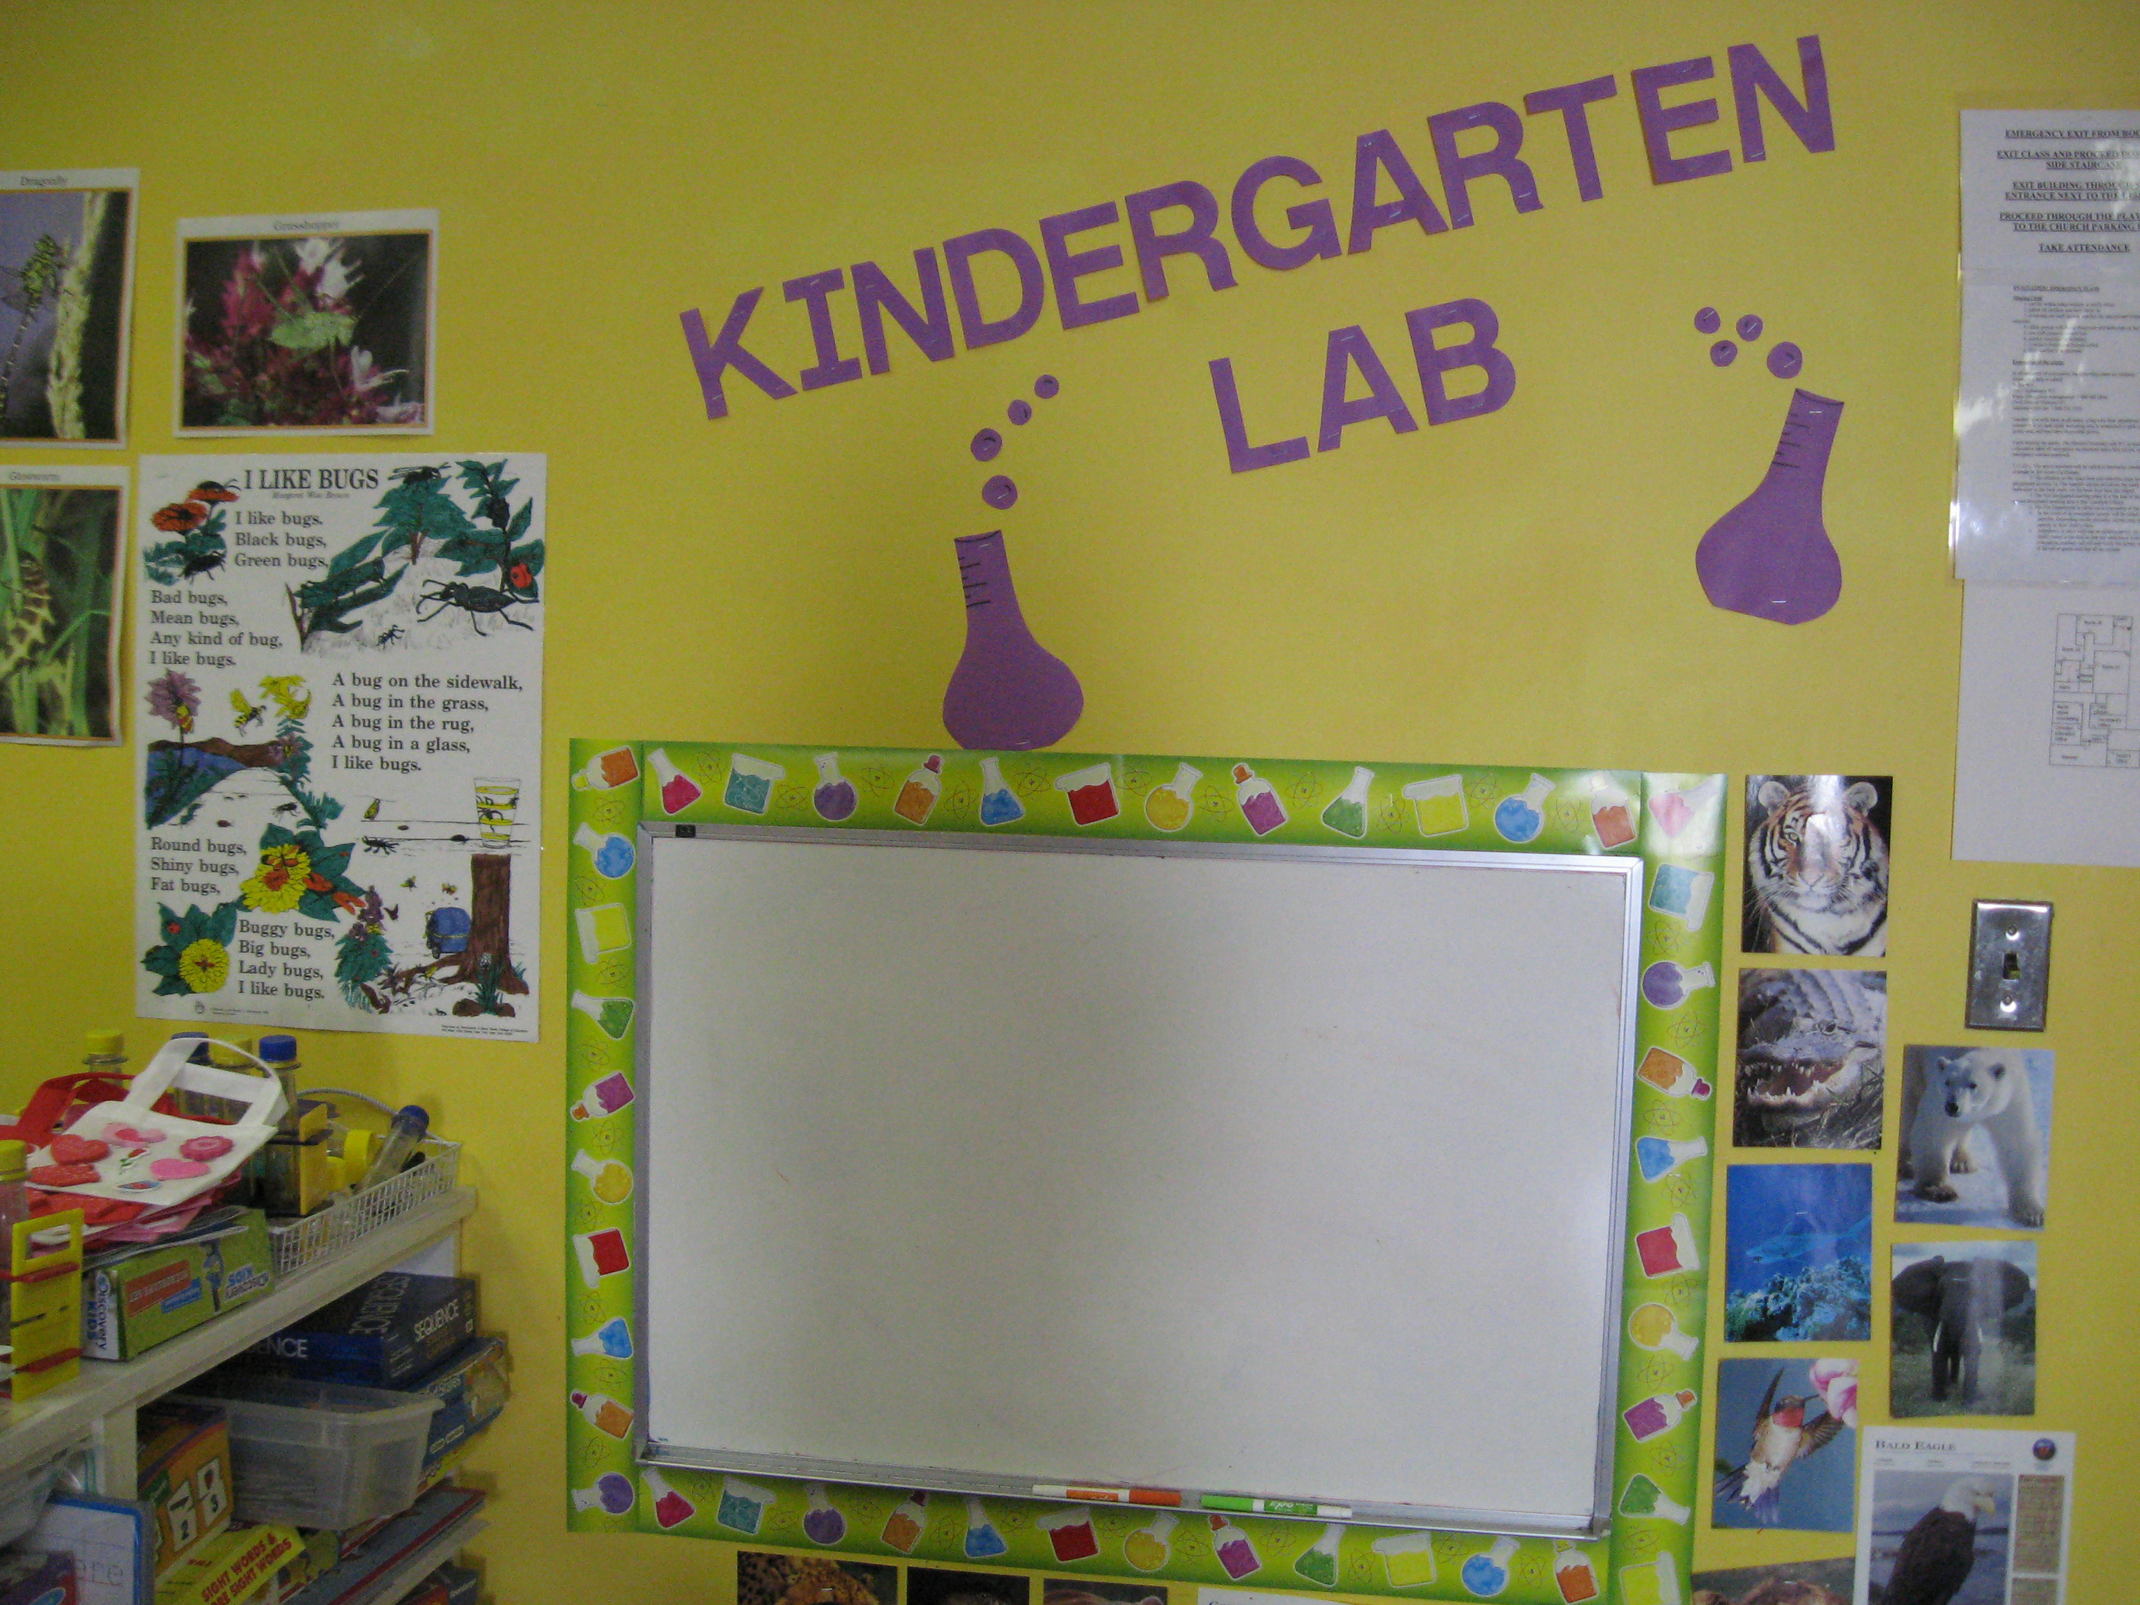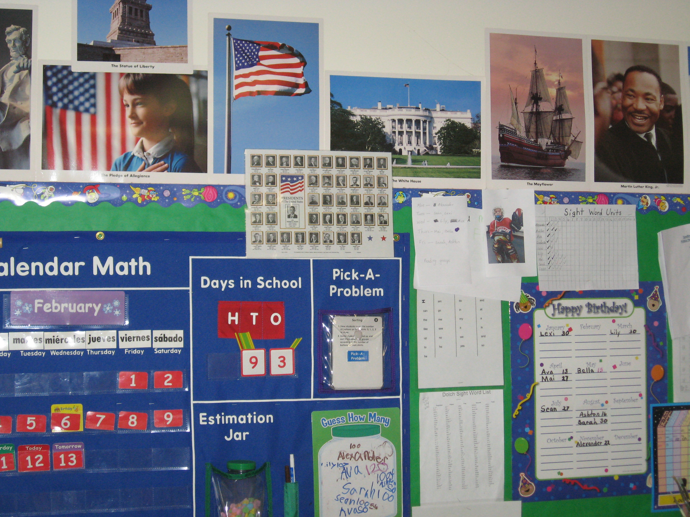

Why choose Tower Day School Kindergarten?
What can Tower Day offer that the public school cannot?

What better way to start your child’s education than in a small, nurturing classroom with significant individual attention! An enriched curriculum aimed at instilling a love of learning while meeting the individual developmental needs of each child are the hallmarks of this program. With a class size of between 9-12 children with a teacher and a teacher assistant, the learning opportunities are endless. The day is full of fun and excitement. Our children not only learn to read and do math, but they have time to discover, investigate, and problem solve.

The Tower Day School Kindergarten Class is a full day program. The class meets on Mondays from 8:30-noon, and then Tuesdays-Fridays from 8:30-2:30. Monday afternoons are used for parent conferences and individual tutoring. Any child who is struggling will stay for extra help on Mondays. Extended day is available in our pre-school for students who need child care on Monday afternoons. The maximum enrollment is 12 children with a teacher and a teacher assistant.
The curriculum is rich in both academic and creative opportunities. Reading instruction, math, science, social studies and writing activities are all part of the Kindergarten curriculum. Art, music, and drama are woven into the program. The classroom computer is used by the students for skill activities and for research. In order to enhance the students’ concepts, there are four field trips each year. The students study beavers and then visit the Ipswich River Wildlife Sanctuary to see beaver lodges and beaver dams. They “go back” to the 17^{tth} – 18th centuries to understand the daily life of early settlers at the Claflin House at the Wenham Museum. A trip to the moon at the Planetarium at the Science Museum caps their study of planets and the solar system. The children also go to the Lynnfield Public Library monthly for non-fiction topics.

The school year begins with individual assessments of the children, using both formal and informal methods. Then, after the teacher has worked with the students for a few weeks, she writes an individual assessment and program plan for each child. Goals are changed as needed. Parent conferences are held every two months.

Priority for enrollment is given to Tower Day School students. Students from outside the school should present a letter from a preschool that indicates the child’s readiness for kindergarten. All families should have their child attend the kindergarten screenings at their local public schools. Please call (781-334-5576) or email (towerdayschool@gmail.com) the Tower Day School office to schedule an appointment to visit the class.

The tuition for 2016/2017 school year is $8,650.00 per year. Tuition plans can be discussed with the Director.

